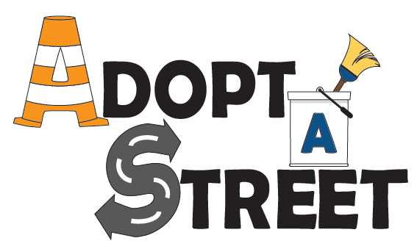

What is the Adopt-A-Street Program?
The Arlington County Solid Waste Bureau (SWB) created the Adopt-A-Street (AAS) Program to advance the County’s goals of stormwater management, litter control, and civic engagement. AAS users volunteer to keep their adopted street free of debris by conducting quarterly cleanups for at least one year.
Who can adopt a street?
Any individual or group in Arlington can adopt a specific section of a street of their choosing – as little as one side of one block or as much as both sides of an entire street – depending on availability.
What are the responsibilities?
- Sweeping and collecting litter and debris from the curb, gutter lines, storm drain, and wheelchair ramps
- Disposing of sweepings in curbside bins or scheduling a pickup by the SWB at 703-228-7610 or arlrecycles@arlingtonva.us
- Reporting hazardous conditions at https://topics.arlingtonva.us/reportproblem/ or by calling:
  - Downed power lines: 1-888-667-3000
  - Streetlight outages: 703-228-6511
  - Damaged/missing street signs: 703-228-6570
  - Potholes or damaged street/sidewalk: 703-228-6570
  - Weeds in the drain: 703-228-6570
- Recording your cleanups on the AAS website: https://egov.arlingtonva.us/des-adopt-a-street/MyStreets.aspx
How do I adopt a street?
Visit https://egov.arlingtonva.us/des-adopt-a-street/ and click Adopt Now. Once you have registered and requested a street, your application will be “Pending” until it is reviewed and approved by the AAS admin team. Once approved, the admin team will reach out via email to coordinate the signing of a liability waiver (https://egov.arlingtonva.us/des-adopt-a-street/email/GroupForm.pdf) and the drop-off of cleaning supplies.

What supplies are provided?
Safety gloves, glasses, vests, and buckets will be provided to AAS users for free. You may keep the supplies until you no longer wish to participate in the AAS program, at which time we ask that you please return the supplies by scheduling a pickup by the SWB at 703-228-7610 or arlrecycles@arlingtonva.us.

